1. **WEB PAGES(Application):**

**This section contains the webpages starting with the home page.**

1. HOME PAGE:

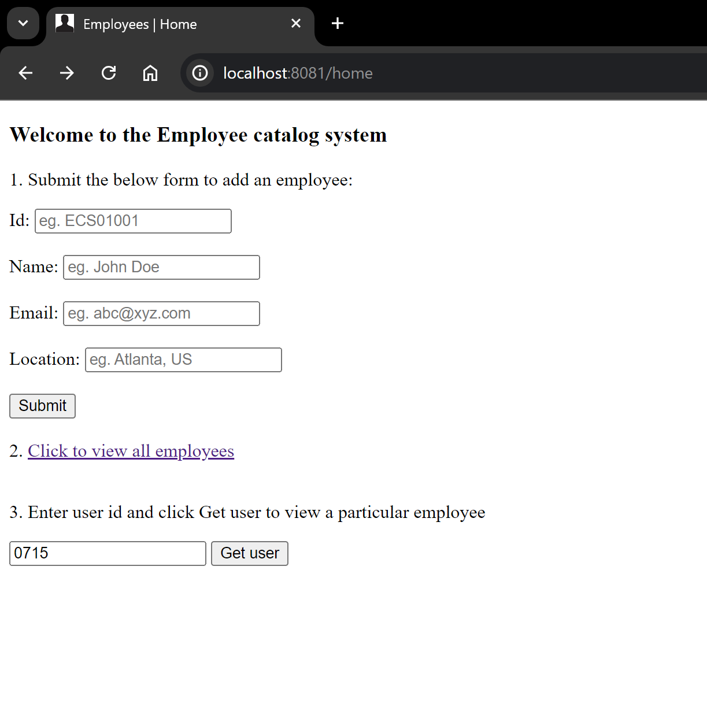

Submitting the form (Add Employee)

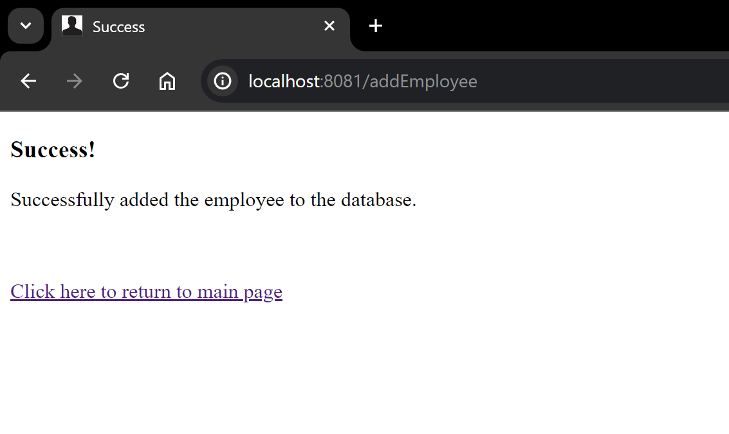

Input validation through spring boot:

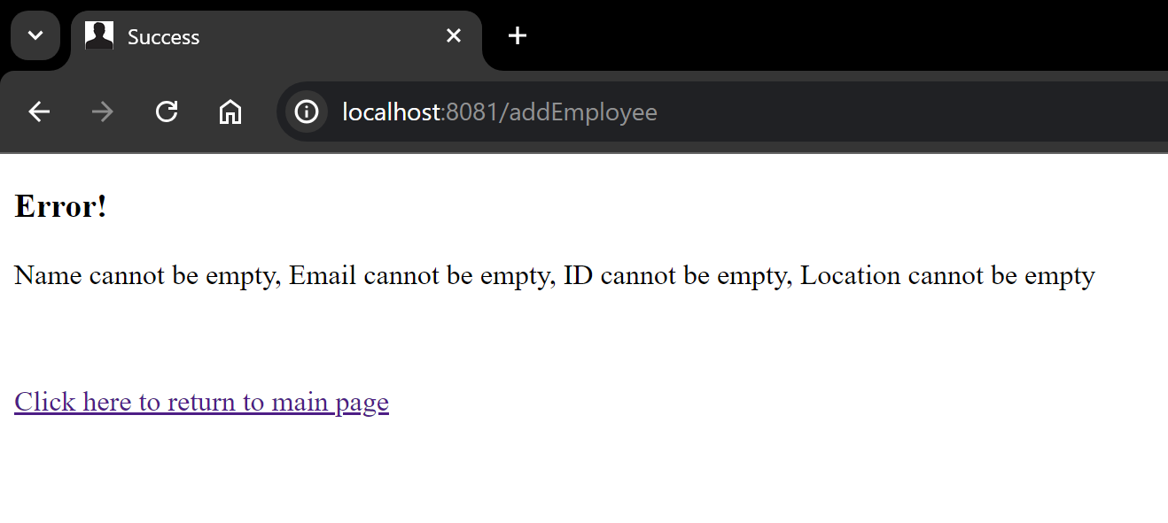

1. DISPLAY EMPLOYEES (Rendered on clicking 2. Click to view all employees)

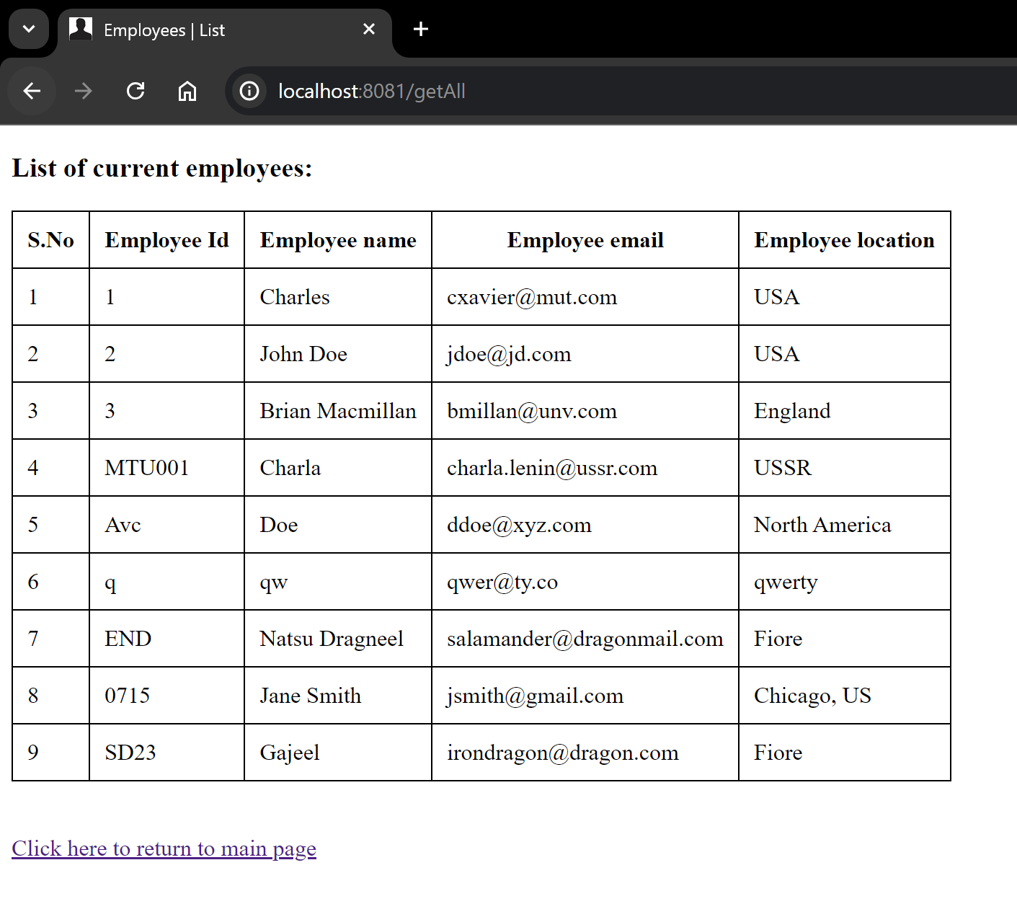

1. Display specific user by id(On providing an id and clicking Get user from home page)

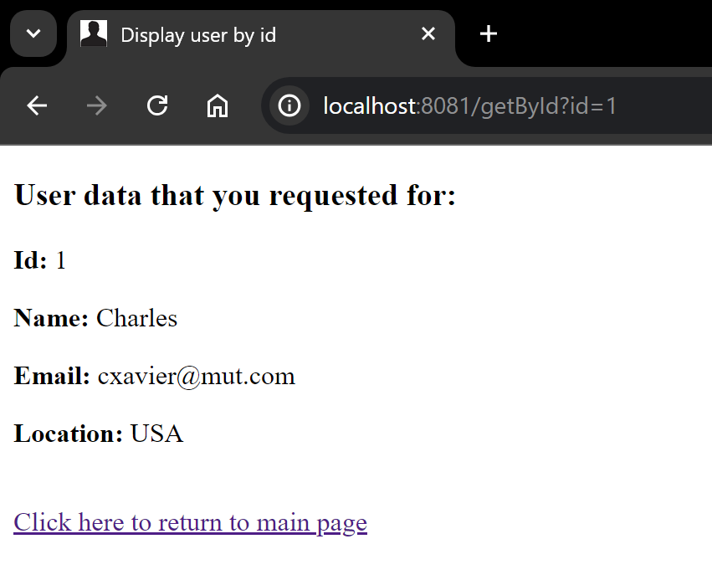

1. **SWAGGER ENDPOINTS:**

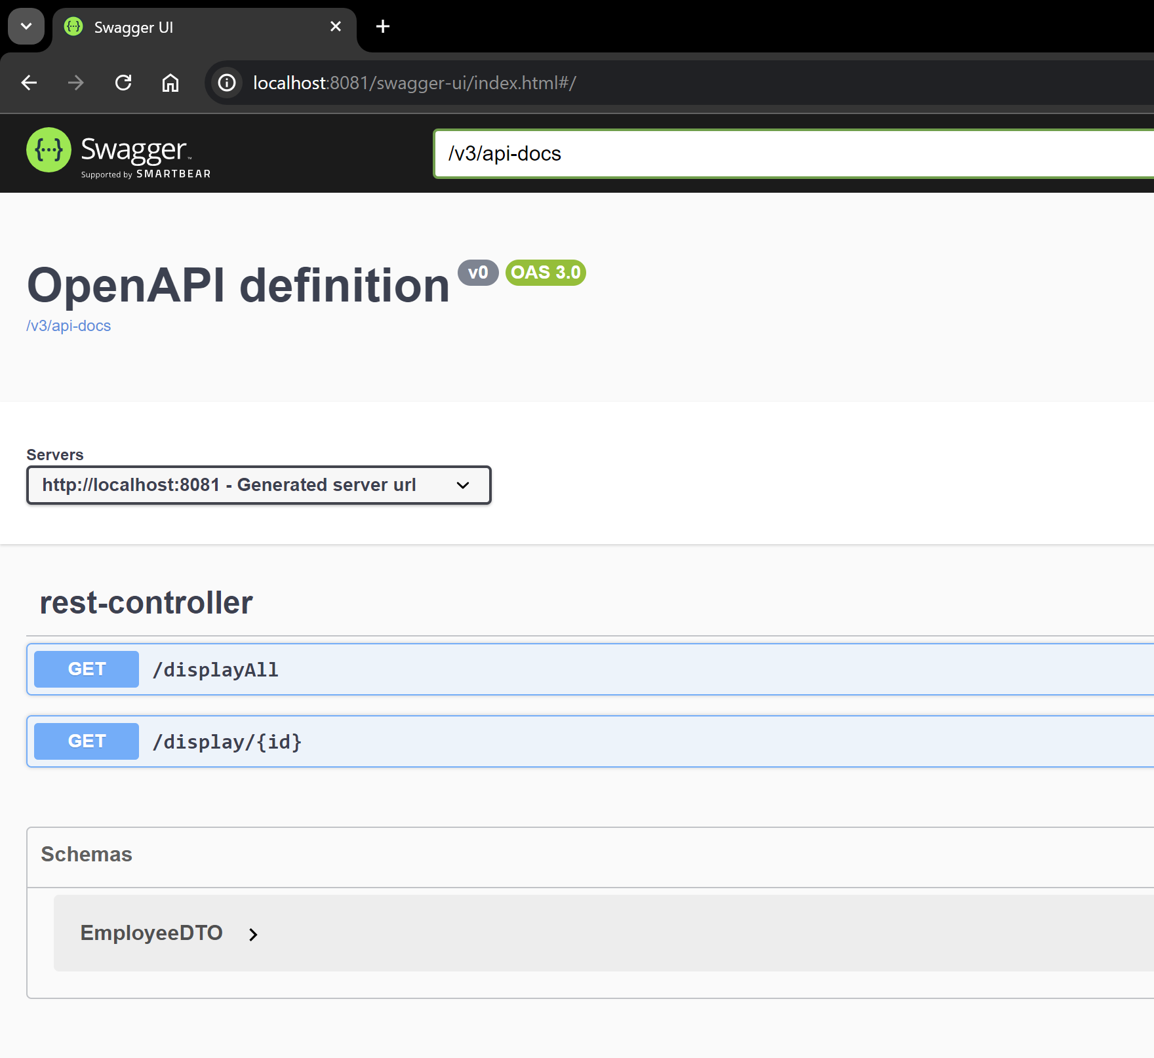

1. /displayAll endpoint

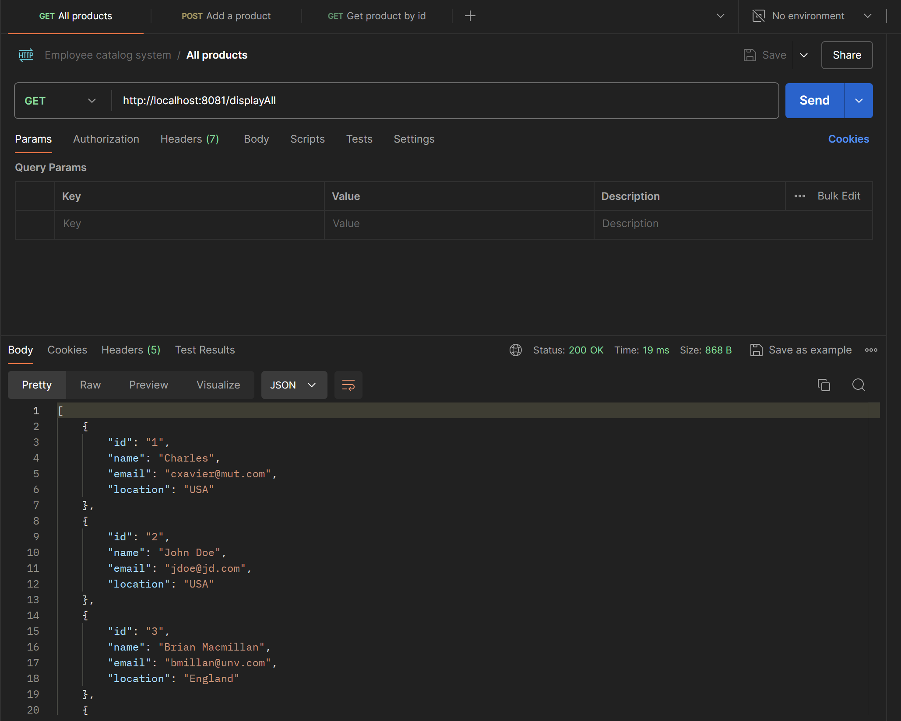

1. /display/{id} endpoint

